**SOUTHWICK PRE-SCHOOL PLAYGROUP**

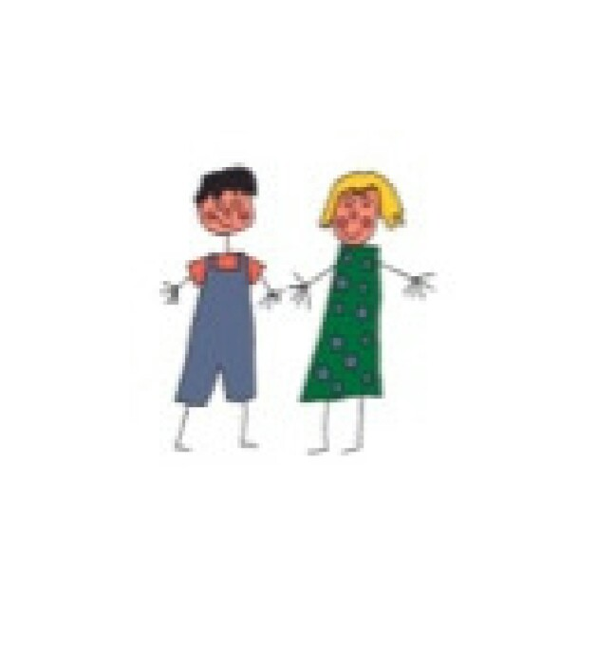

**Registration Form**

**Key Information**

|  |  |  |  |  |  |  |  |  |  |  |  |  |  |  |  |  |  |  |  |  |  |  |
| --- | --- | --- | --- | --- | --- | --- | --- | --- | --- | --- | --- | --- | --- | --- | --- | --- | --- | --- | --- | --- | --- | --- |
| Child’s Surname | |  | | | | | | | | | | | | | | | | | | | | |
| Child’s First Name(s) | |  | | | | | | | | | | | | | | | | | | | | |
| Known As | |  | | | | | | | | | | | | | | | | | | | | |
| Date Of Birth | |  | | | | | | | | | | | | | | | | | | | | |
| Sex | | Boy |  | | | | | | Girl | | | |  | | | | | | | | | |
| Religion | |  | | | | Ethnicity | | | | | | |  | | | | | | | | | |
| First Language | |  | | | | | | | | | | | | | | | | | | | | |
| Any Other Language spoken | |  | | | | | | | | | | | | | | | | | | | | |
| **Parent/Carer 1** | | Relationship to the child | | | | | | | | | | | |  | | | | | | | | |
| Parental Responsibility | | | | | | | | | | | | Yes | | | | | | | No | |
| Name | |  | | | | | | | | | | | | | | | | | | | | |
| National Insurance Number | |  | | | | | | | | | | | | | | | | | | | | |
| Address | |  | | | | | | | | | | | | | | | | | | | | |
|  | | | | | | | | | | | | | | | | | | | | |
|  | | | | | | | | | | | | Post Code | | | | |  | | | |
| Email Address | |  | | | | | | | | | | | | | | | | | | | | |
| Telephone Number | | Home | |  | | | | | | | Mobile | | | | | |  | | | | | |
| Place of Work | |  | | | | | | | | | | | | | | | | | | | | |
| Job Title | |  | | | | | | Dept | | | |  | | | | | | | | | | |
| Address | |  | | | | | | | | | | | | | | | | | | | | |
|  | | | | | | | | | | | | | | | | | | | | |
|  | | | | | | | | | | | | | | Post Code | | | |  | | |
| Telephone Number | |  | | | | | | | | Ext. | | | | | |  | | | | | | |
| Able To Collect Child | | Yes |  | | | | | | | No | | | | | |  | | | | | | |
| **Parent/Carer 2** | | Relationship to the child | | | | | | | | | | | | | |  | | | | | | |
| Parental Responsibility | | | | | | | | | | | | | | Yes | | | | | | No |
| Name | |  | | | | | | | | | | | | | | | | | | | | |
| National Insurance Number | |  | | | | | | | | | | | | | | | | | | | | |
| Address | |  | | | | | | | | | | | | | | | | | | | | |
|  | | | | | | | | | | | | | | | | | | | | |
|  | | | | | | | | | | | | | Post Code | | | | | |  | |
| Email Address | |  | | | | | | | | | | | | | | | | | | | | |
| Telephone Numbers | | Home | | |  | | | | | | | | Mobile | | | | |  | | | | |
| Place of Work | |  | | | | | | | | | | | | | | | | | | | | |
| Job Title | |  | | | | | | Dept | | | |  | | | | | | | | | | |
| Address | |  | | | | | | | | | | | | | | | | | | | | |
|  | | | | | | | | | | | | | | | | | | | | |
|  | | | | | | | | | | | | | | Post Code | | | |  | | |
| Telephone Number | |  | | | | | | | | Ext. | | | | | |  | | | | | | |
| Able To Collect Child | | Yes |  | | | | | | | No | | | | | |  | | | | | | |
|  | | | | | | | | | | | | | | | | | | | | | | |
| Do any other individuals have Legal contact arrangements with the child | | | | | | | | | | | | | | | | Yes | | | | | No | |
| If Yes please provide details below and a copy of relevant documentation | | | | | | | | | | | | | | | | | | | | | | |
| **Emergency Contacts Other Than Parents/Carers** | | | | | | | | | | | | | | | | | | | | | | |
|  | Contact No. 1 | | | | | | Contact No. 2 | | | | | | | | | | | | | | | |
| Name |  | | | | | |  | | | | | | | | | | | | | | | |
| Relationship To  Child |  | | | | | |  | | | | | | | | | | | | | | | |
| Address |  | | | | | |  | | | | | | | | | | | | | | | |
| Tel. No |  | | | | | |  | | | | | | | | | | | | | | | |
| Mobile No. |  | | | | | |  | | | | | | | | | | | | | | | |
| Password for  Collecting child |  | | | | | |  | | | | | | | | | | | | | | | |
| **Sessions Required** | | | | | | | | | | | | | | | | | | | | | | |

|  |  |  |  |  |  |
| --- | --- | --- | --- | --- | --- |
|  | MONDAY | TUESDAY | WEDNESDAY | THURSDAY | FRIDAY |
| Am Session |  |  |  |  |  |
| Pm Session |  |  |  |  |  |
| Full Day |  |  |  |  |  |
| Additional Requirements |  |  |  |  |  |
| Start Date | S | | | | |

**Medical Details**

|  |  |  |  |  |  |  |  |
| --- | --- | --- | --- | --- | --- | --- | --- |
| Doctors Name: |  | | | | | | |
| Address |  | | | | | | |
| Tel. No. |  | | | | | | |
| Health Visitor Name |  | | | | | | |
| Address |  | | | | | | |
| Tel No. |  | | | | | | |
|  | | | | |  | |  |
|  | | | | | | | |
| Are there any other services involved with the child or family ? | | | | | | | |
| Health visitor | Yes | No | Date Involvement commenced | | |  | |
| Name |  | | | | | | |
| Contact Information and Telephone Number |  | | | | | | |
| Social Worker | Yes | No | Date Involvement commenced | | |  | |
| Name |  | | | | | | |
| Contact Information and Telephone Number |  | | | | | | |
| Speech and Language | Yes | No | Date Involvement commenced | | |  | |
| Name |  | | | | | | |
| Contact Information and Telephone Number |  | | | | | | |
|  |  |  |  | | |  | |
| Early Help Team |  | | | | | | |
| Name |  | | | | | | |
| Contact number |  |  |  | | |  | |
|  |  | | | | | | |
|  |  | | | | | | |
| Any Other Service | Date Involvement Commenced | | |  | | | |
| Main Service Provided |  | | | | | | |
| Main Contact Name |  | | | | | | |
| Contact Information and Telephone Number |  | | | | | | |

**Immunisations – Please Tick If Your Child Has Been Vaccinated Against The Following:**

|  |  |  |  |  |  |  |  |  |  |  |
| --- | --- | --- | --- | --- | --- | --- | --- | --- | --- | --- |
|  | Yes | No | |  | | | Yes | | | No |
| Diphtheria |  |  | | Tetanus | | |  | | |  |
| Hib |  |  | | Mumps | | |  | | |  |
| Measles |  |  | | Rubella | | |  | | |  |
| Polio |  |  | | Whooping Cough | | |  | | |  |
| Details Of Other Vaccinations | |  | | | | | | | | |
| Has Your Child Had Any Infectious Diseases? | | | | | Yes |  | | No |  | |
| If Yes Please Give Details | | |  | | | | | | | |

**Individual Requirements and Details**

|  |  |  |  |  |  |  |  |  |  |  |  |  |  |
| --- | --- | --- | --- | --- | --- | --- | --- | --- | --- | --- | --- | --- | --- |
| Has Your Child Any Food Allergies or Special Dietary Requirements? | | | | | Yes |  | | No | | |  | | |
| Please Give Details |  | | | | | | | | | | | | |
| Are There Any Foods You Do Not Want Your Child To Have? | | | Yes | | |  | | | No | | |  | |
| Please Give Details | |  | | | | | | | | | | | |
| Has Your Child Any Cultural Or Religious Requirements? | | | | Yes | | |  | | | No | | |  |
| Please Give Details | |  | | | | | | | | | | | |
| Any Other Details That May Be Useful | |  | | | | | | | | | | | |

|  |  |  |  |  |  |
| --- | --- | --- | --- | --- | --- |
| **Consents** | | | | | |
| **Medical Treatment** | | | | | |
| **I hereby give consent for the staff of Southwick playgroup to** … | | | | | |
| Administer Emergency First Aid | Yes | | | No | |
| Seek Emergency medical and dental attention including hospital treatment if it is deemed necessary | Yes | | | No | |
| Administer medication | Yes | | | No | |
| To apply a plaster when necessary | Yes | | No | | |
| To apply sun cream factor 30+. I understand that is my responsibility to provide sun cream hat and appropriate clothing during the summer months | Yes | | No | | |
| Signature…………………………………………………. Date ………………………………………… | | | | | |
|  | | | | | |
| **Outings** | | | | | |
| **I hereby give consent for the staff of Southwick Playgroup to** … | | | | | |
| To take my child on local visits and outings | | Yes | | | No |
| To travel on a mini bus staff’s personal transport or other parent`s personal transport | | Yes | | | No |
| To travel on public transport or hired coaches | | Yes | | | No |
| Signature…………………………………………………. Date ……………………………………… | | | | | |
|  | | | | | |
| **Photographs** | | | | | |
| **I hereby give consent for the staff of Southwick Playgroup to** … | | | | | |
| Photograph my child and for those photographs to be used in my child’s file and displays around the setting | | Yes | | | No |
| Use photographs of my child taken at Southwick playgroup in another child’s file or diary (as a group) | | Yes | | | No |
| Use photographs of my child in newsletters | | Yes | | | No |
| Use photographs of my child on the playgroup’s website | | Yes | | | No |
| Use photographs of my child for advertising purposes | | Yes | | | No |
| Signature…………………………………………………. Date ………………………………………… | | | | | |
|  | | | | | |

|  |  |  |
| --- | --- | --- |
| **Sharing information** | | |
| **I hereby give consent for the staff of Southwick playgroup to** … | | |
| Share information about my child with other agencies such as :  Speech and Language, Health Visitors, Special educational need support | Yes | No |
| Signature................................................................ Date...................................................................  **Please note staff will share information without consent if they are concerned about the welfare of the child** | | |

As security is of the utmost importance we request that you inform the playgroup of any delay or changes to collection arrangements. The person collecting your child should be known to the

nursery and be aware of your chosen password.

Please report and sign in the book any injures which have occurred at home when you bring the child in the setting so we know that it hasn`t happened at the setting when staff notices a scratch or a bruise.

Thank you for your co-operation - the safety and welfare of your child is a priority number one in our setting and having full and current information is very important.

PLEASE LET US KNOW OF ANY CHANGES - PHONE NUMBERS, ADDRESSES !!!